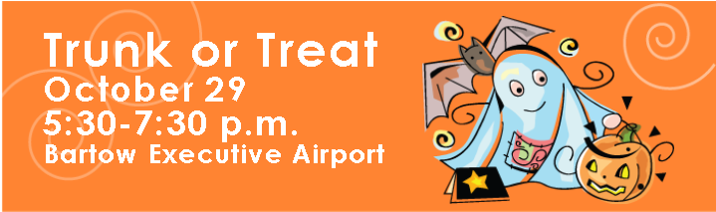
The Bartow Executive Airport will be hosting a Trunk or Treat for all youth on October 29th from 5:30 – 7:30 p.m.
- Aircraft Trunk or Treat
- Free Candy and Goodies
- Raffles and Prizes including a Discovery Flight
- Static Aircraft Display
- Firetruck
- Sheriff’s Office Swamp Buggy
- Restaurant Specials
- WWII Airbase Museum
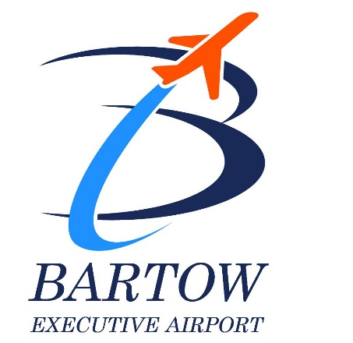
- Photo Booth

5993 Airport Blvd
Bartow, FL 33830
(863) 533-1195

